4. VACUUM CLEANER PROBLEM
Aim
To implement the Vacuum Cleaner Problem using Python to clean all dirty rooms.
Objective
- To understand the working of the Vacuum Cleaner Problem.
- To identify whether a room is clean or dirty.
- To clean all dirty rooms.
- To display the final cleaned environment.
Algorithm
- Start.
- Initialize two rooms (A and B) with their states (Dirty or Clean).
- Place the vacuum cleaner in the first room.
- Check whether the current room is dirty.
- If the room is dirty, clean it.
- Move the vacuum cleaner to the next room.
- Repeat Steps 4–6 until all rooms are checked.
- Display the final state of both rooms.
- Stop.

Flowchart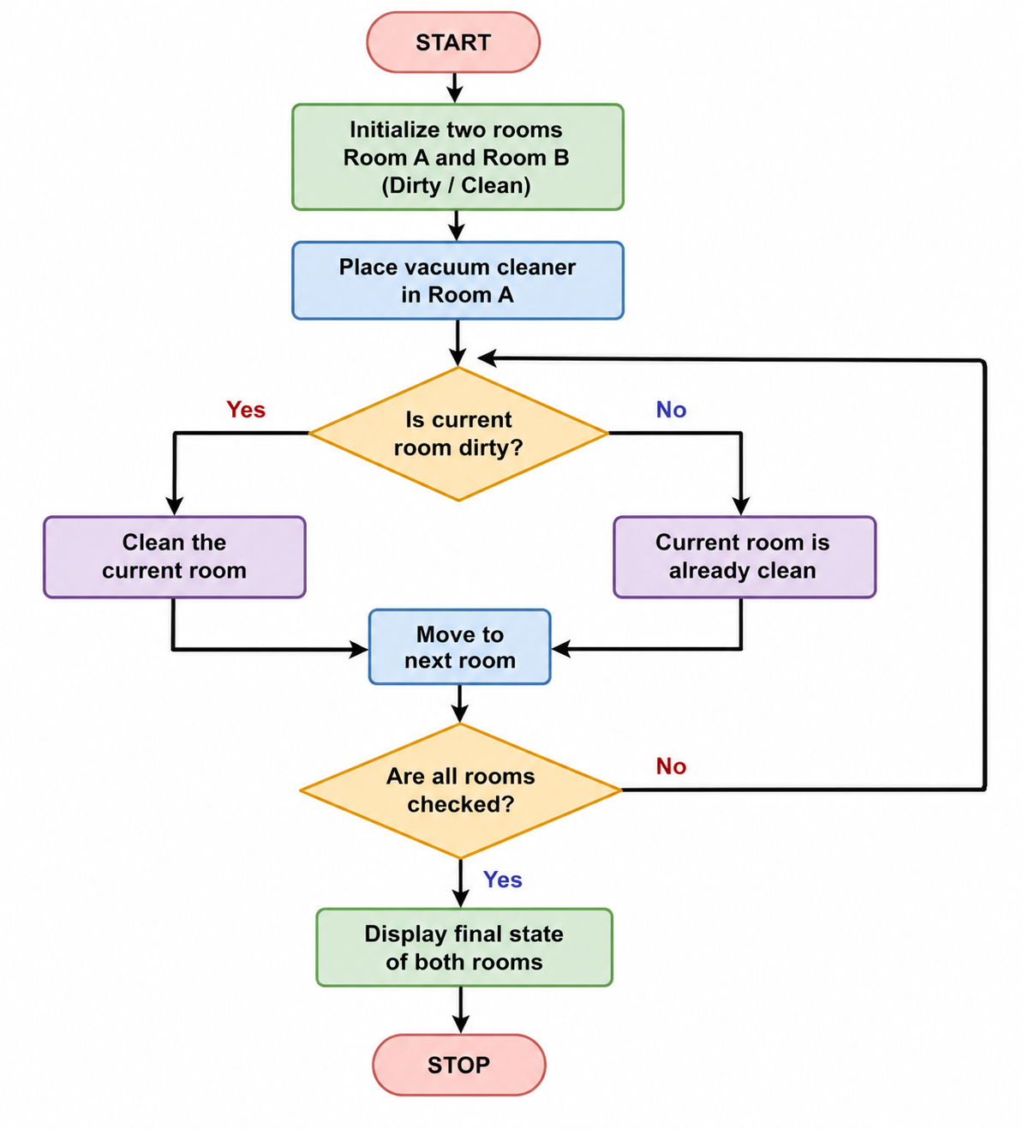
Code
rooms = ["Dirty", "Dirty"]

for i in range(2):

if rooms[i] == "Dirty":
print("Room", i + 1, "is Dirty")
print("Cleaning Room", i + 1)
rooms[i] = "Clean"

else:
print("Room", i + 1, "is Already Clean")

print("\nFinal State:")

for i in range(2):
print("Room", i + 1, "=", rooms[i])

print("\nAll Rooms are Clean")
Output
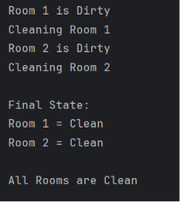
Result
The Vacuum Cleaner Problem was successfully implemented in Python. The vacuum cleaner checked each room, cleaned all dirty rooms, and displayed the final state showing that all rooms are clean.

